====================================================================
- Divide and Conquer, Sorting and Searching, and Randomized Algorithms – Split (Divide), solve subproblems recursively (Conquer), combine (Merge)
  - Week 1: Why algorithms matter, how to design clever ones, and perform asymptotic analysis via big o notation
  - Week 2:
    - Counting Inversions – Divide, count reclusively inversions for left and right, then when merging count the split inversions
    - Introduces a method to solve recurrences, Master Method – TC of Recursive algos
    - Strassen sub cubic matrix multiplication algo, he improves O(n^3)
    - Closest Pair algo
  - Week 3:
    - Quicksort – A sorting algo, and randomized QS for pivot selection
    - Probability concepts
      - Expectation (Average value expected in a long run)
      - Independence
  - Week 4:
    - Use Randomness to solve problems, like selectsion problem and Mini
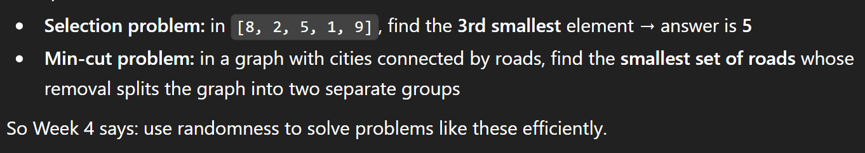
====================================================================
- Graph Search, Shortest Paths, and Data Structures - This work focuses on how to represent problems as graphs and use efficient algorithms to search through them and find the shortest route between points.
It also introduces important data structures, like stacks, queues, heaps, and hash tables, which help make these graph algorithms faster and more organized.

  - Week 1:
  - Week 2:
  - Week 3:
  - Week 4:
====================================================================
- Greedy Algorithms, Minimum Spanning Trees, and Dynamic Programming
====================================================================
- Shortest Paths Revisited, NP-Complete Problems and What To Do About Them
====================================================================
Divide and Conquer, Sorting and Searching, and Randomized Algorithms – Resources: ->
Week 1:
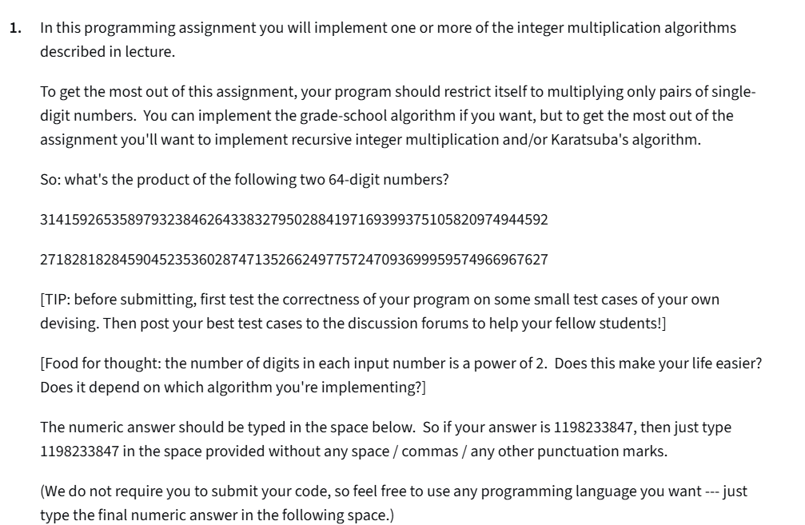
Answer: 8539734222673567065463550869546574495034888535765114961879601127067743044893204848617875072216249073013374895871952806582723184

Week 2:
DIVIDE AND CONQUER ALGORITHMS: The next set of lectures discusses three non-trivial examples of the divide and conquer algorithm design paradigm. The first is for counting the number of inversions in an array. This problem is related to measuring similarity between two ranked lists, which in turn is relevant for making good recommendations to someone based on your knowledge of their and others' preferences ("collaborative filtering"). The second algorithm is Strassen's mind-blowing recursive algorithm for matrix multiplication, which improves over the obvious iterative method. The third algorithm, which is more advanced and is optional material, is for computing the closest pair of points in the plane.
THE MASTER METHOD: These lectures cover a "black-box" method for solving recurrences. You can then immediately determine the running time of most of the divide-and-conquer algorithms that you'll ever see! (Including Karatsuba's integer multiplication algorithm from Week 1.) The proof is a nice generalization of the recursion tree method that we used to analyze MergeSort. Ever wonder about the mysterious three cases of the Master Method? Watch these videos and hopefully all will become clear.
HOMEWORK: Problem Set #2 has five questions that should give you practice with divide-and-conquer algorithms and the Master Method. Programming assignment #2 asks you to implement the counting inversions algorithm (from Part III) in whatever programming language you please, run it on a quite large input, and enter the answer.
SUGGESTED READING FOR WEEK 2: Algorithms Illuminated (Part 1), Chapters 3 and 4.
Completed

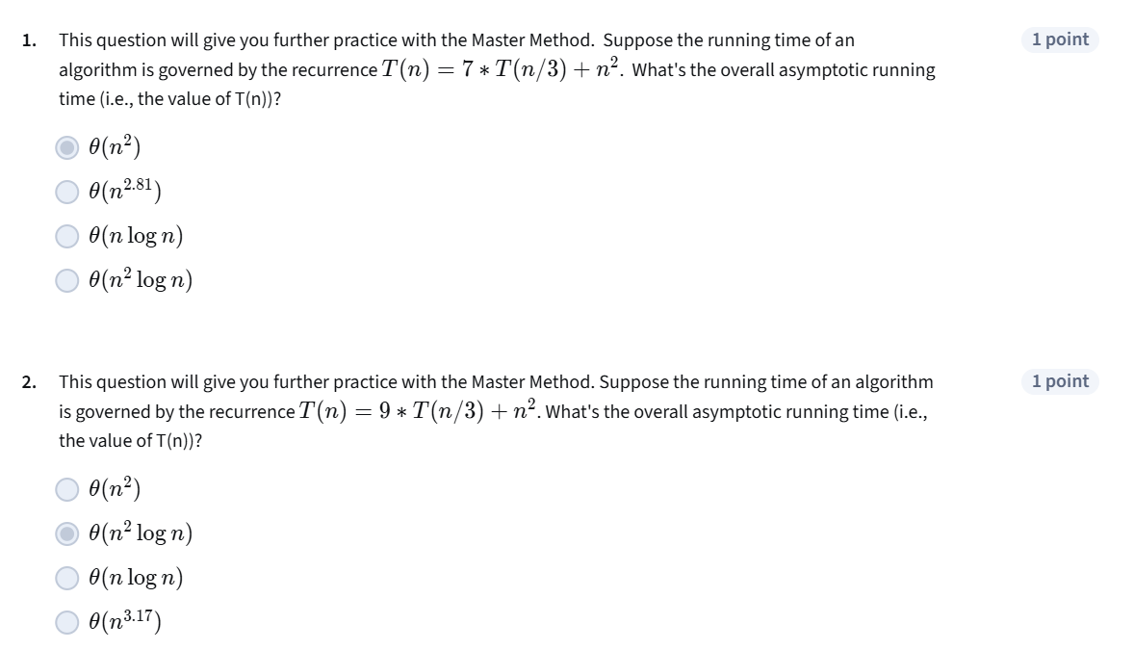
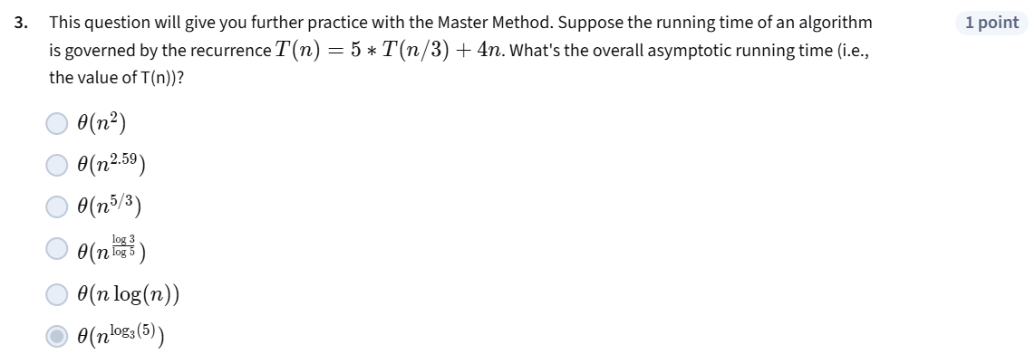
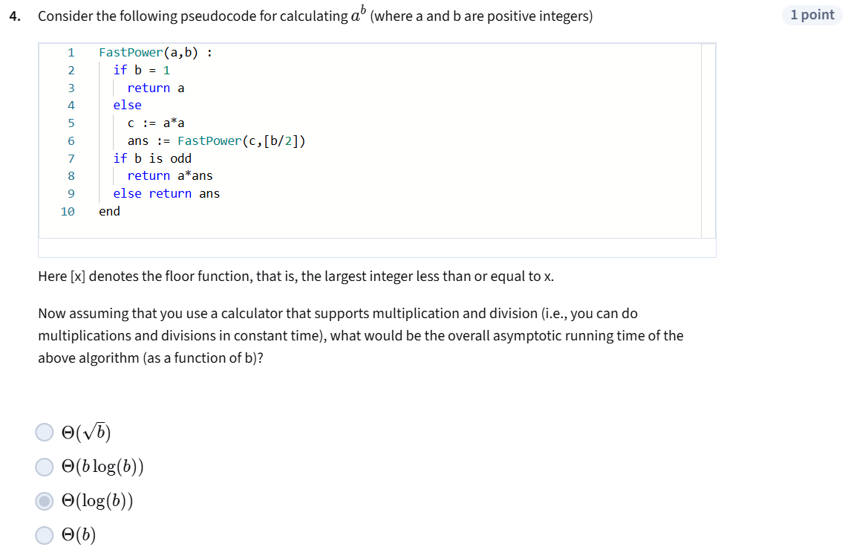
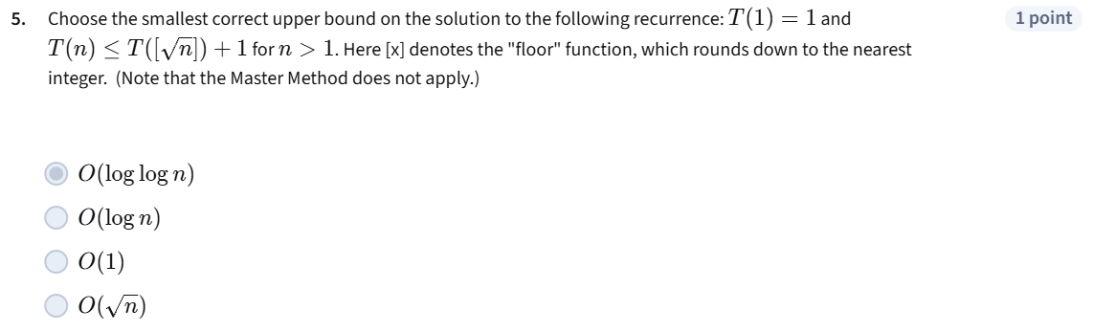
Programming assignment 2:
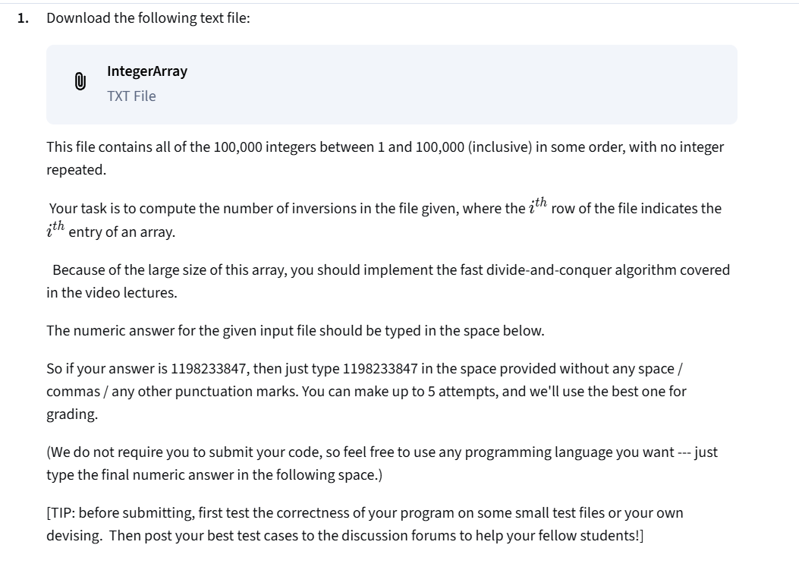

Week 3:
QUICKSORT - THE ALGORITHM (Part V). One of the greatest algorithms ever, and our first example of a randomized algorithm. These lectures go over the pseudocode --- the high-level approach, how to partition an array around a pivot element in linear time with minimal extra storage, and the ramifications of different pivot choices --- and explain how the algorithm works.
QUICKSORT - THE ANALYSIS (Part VI). These lectures prove that randomized QuickSort (i.e., with random pivot choices) runs in O(n log n) time on average. The analysis is as elegant as the algorithm itself, and is based on a "decomposition principle" that is often useful in the analysis of randomized algorithms. Note that there are some accompanying lecture notes for this part (available for download underneath each video). Also, it may be helpful to watch the first probability review video (below) before watching this sequence.
PROBABILITY REVIEW (Part VII). This first of these videos reviews the concepts from discrete probability that are necessary for the QuickSort analysis --- sample spaces, events, random variables, expectation, and linearity of expectation. The second video covers just two topics, although quite tricky ones! (Namely, conditional probability and independence.) You need to review these two topics (via this video or some other source, as you wish) before studying the analysis of the randomized contraction algorithm in Week 4.
HOMEWORK: This week's quiz will help you understand QuickSort and probability more deeply. Programming Assignment #3 asks you to implement QuickSort and compute the number of comparisons that it makes for three different pivot rules.
SUGGESTED READING FOR WEEK 3: Algorithms Illuminated (Part 1), Chapter 5 and Appendix B.

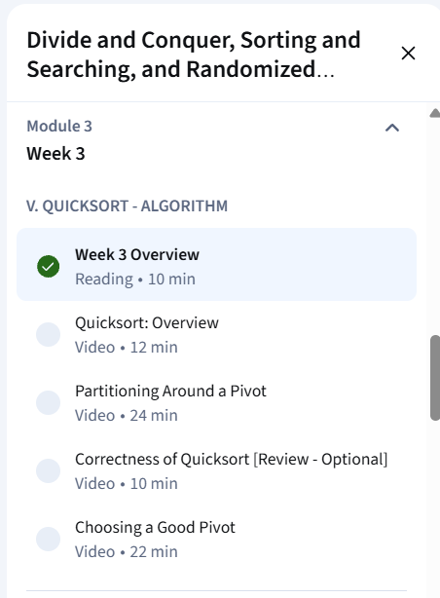
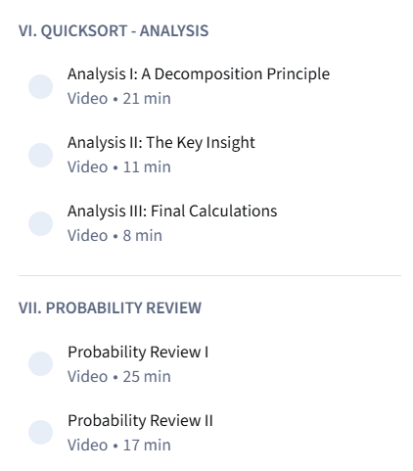

Problem Set #3:
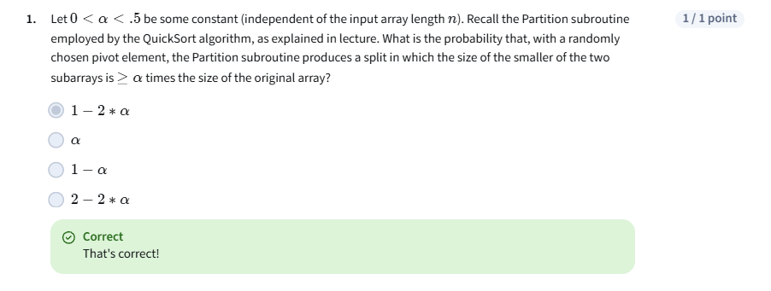
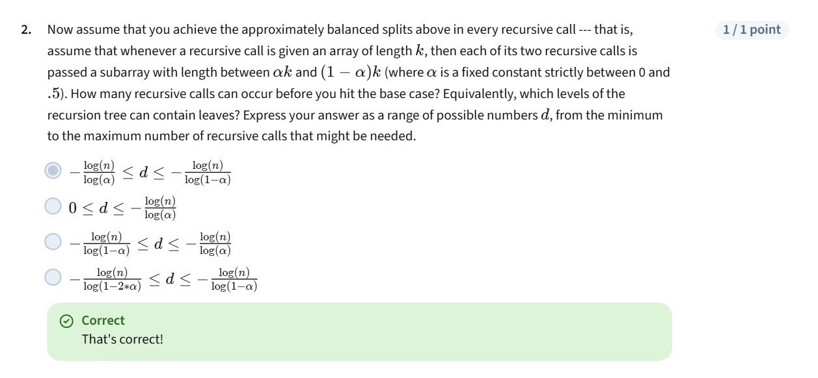

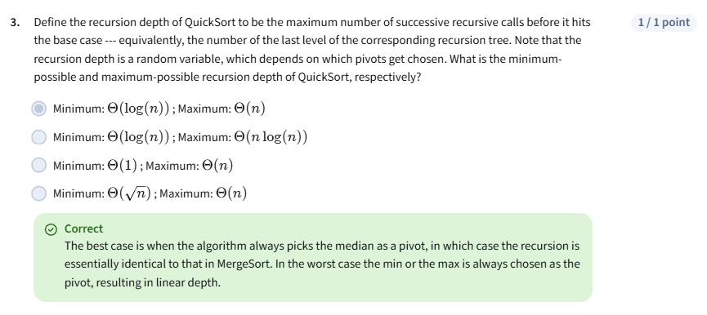
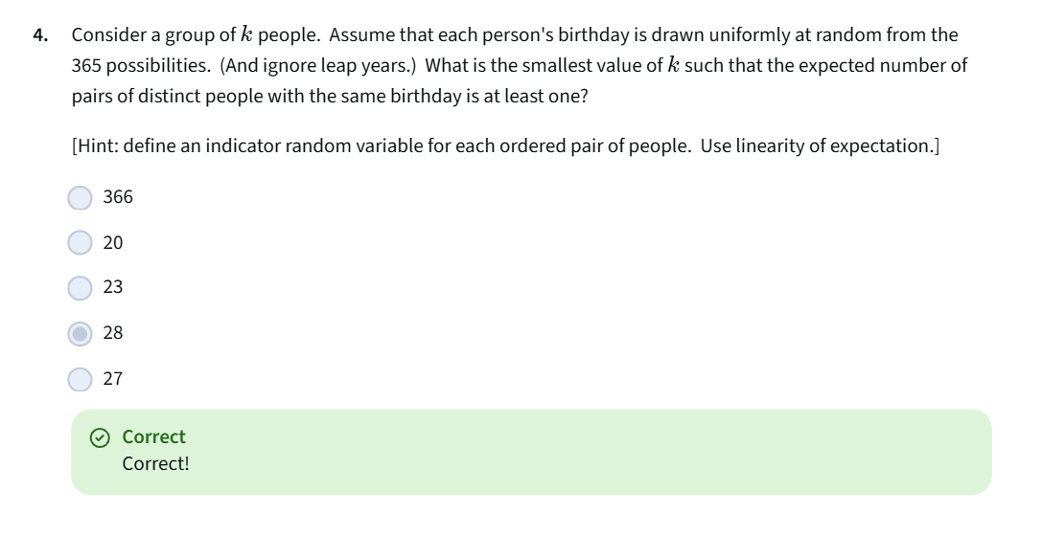
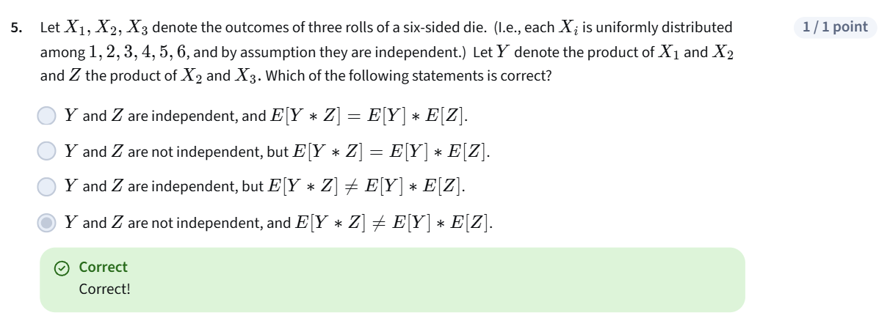
Programming Assignment #3
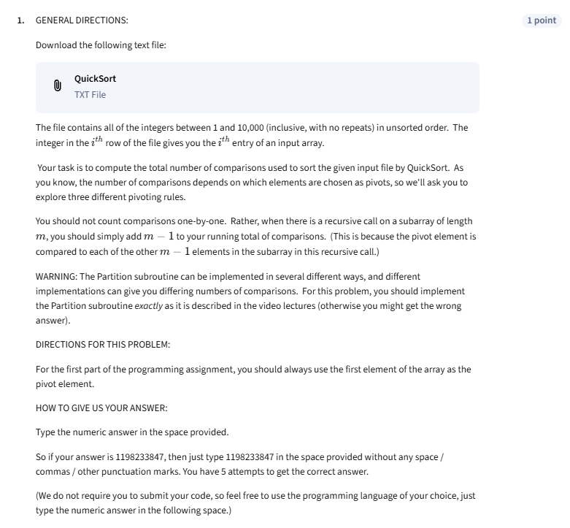
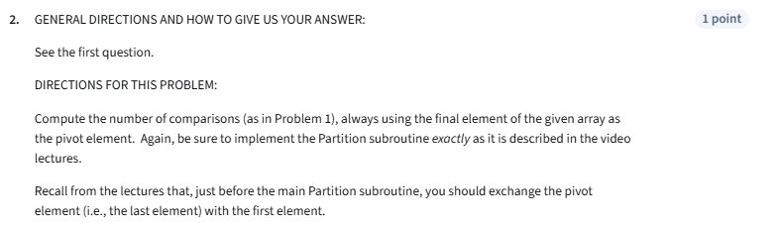
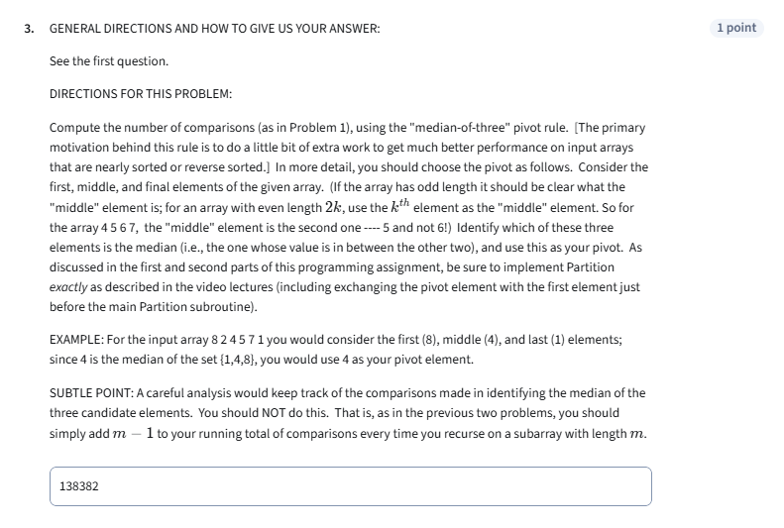

Week 4:
Part VIII --- LINEAR-TIME SELECTION (Required). These lectures study the problem of computing the ith smallest element of an input array (e.g., the median). It's easy to solve this problem in O(n log n) time using sorting, but we can do better! The required material goes over a super-practical randomized algorithm, very much in the spirit of QuickSort, that has *linear* expected running time. Don't forget that it takes linear time just to read the input! The analysis is somewhat different than what we studied for QuickSort, but is equally slick. Basically, there's a cool way to think about the progress the algorithm makes in terms of a simple coin-flipping experiment. Linearity of expectation (yes, it's back...) seals the deal.
Part VIII --- LINEAR-TIME SELECTION (Optional). I couldn't resist covering some advanced related material. The first is an algorithm that has more Turing Award-winning authors than any other algorithm that I know of. It is a deterministic (i.e., no randomization allowed) linear-time algorithm for the Selection problem, based on an ingenious "median-of-medians" idea for guaranteeing good pivot choices. (There are some accompanying lectures notes for this part, available for download underneath each video.) The second optional topic answers the question "can we do better?" for sorting, unfortunately in the negative. That is, a counting argument shows that there is no "comparison-based" sorting algorithm (like MergeSort, QuickSort, or HeapSort) with worst-case running time better than n log n.
Part IX --- GRAPHS AND THE CONTRACTION ALGORITHM. The second set of lectures for this week is a segue from randomized algorithms to graph algorithms. We first review graphs and the most standard ways of representing them (most commonly, by adjacency lists). We then consider the random contraction algorithm, discovered by Karger "only" 20ish years ago (while a PhD student here at Stanford). This algorithm solves the minimum cut problem --- given an undirected graph, separate the vertices into two non-empty groups to minimize the number of "crossing edges". Such problems come up when reasoning about, for example, physical networks, social networks, and images. This algorithm was perhaps the first strong evidence that graph problems could be added to the long list of "killer applications" of random sampling. Don't tune out before the final plot twist --- a simple but useful trick for transforming an algorithm that almost always fails into one that almost always succeeds.
HOMEWORK: Problem Set #4 has five questions about the randomized selection algorithm, cuts in graphs, and the contraction algorithm. Programming Assignment #4 asks you to implement the contraction algorithm and use it to compute the min cut of the graph that we provide.
SUGGESTED READINGS FOR WEEK 4: Algorithms Illuminated (Part 1), Chapter 6.
For a textbook treatment of the contraction algorithm, see Kleinberg and Tardos, Algorithm Design, Sections 13.2 and 13.5.
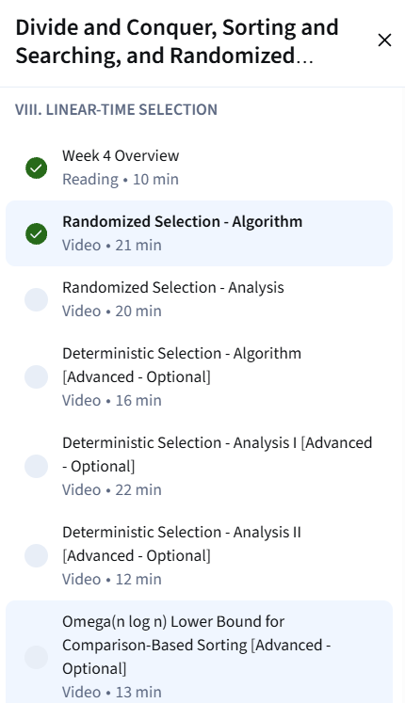
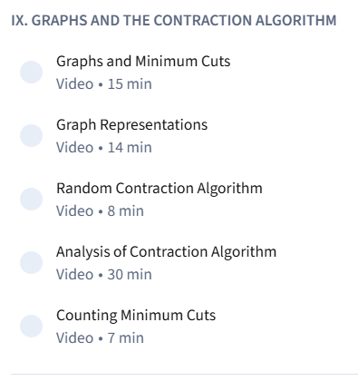
Problem set #4
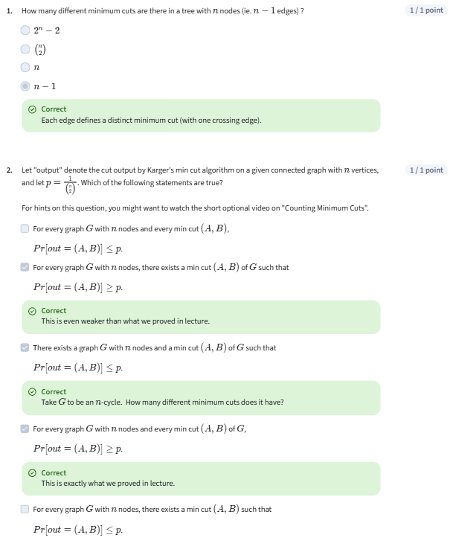
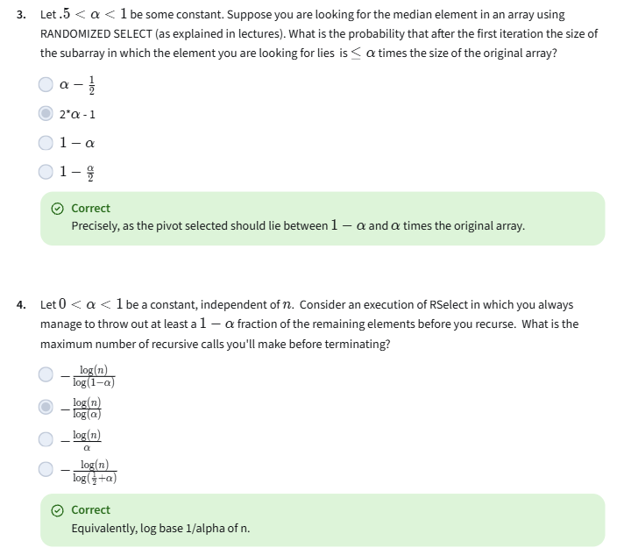
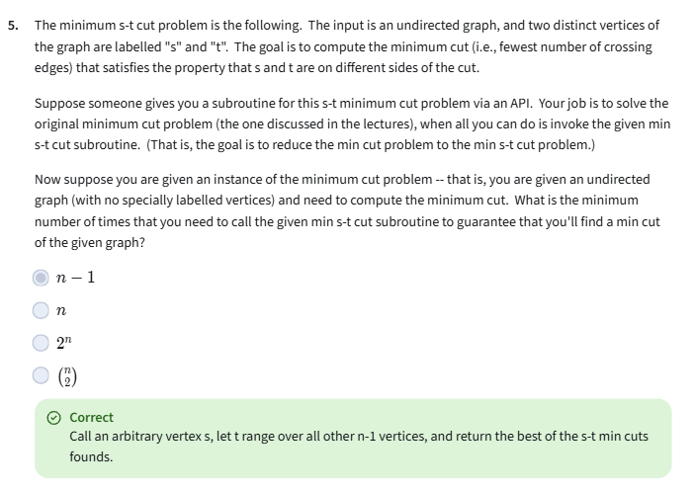
Optional Questions
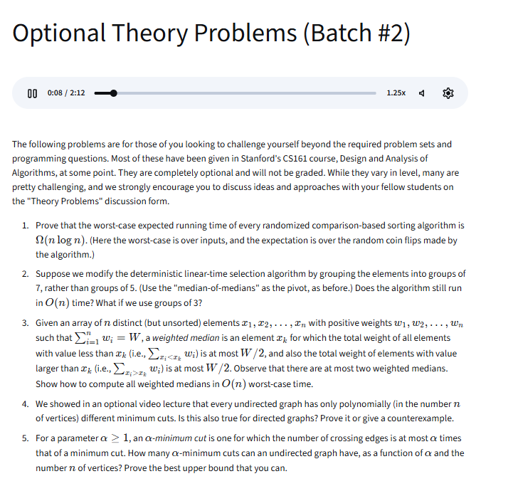
Programming Assignment #4
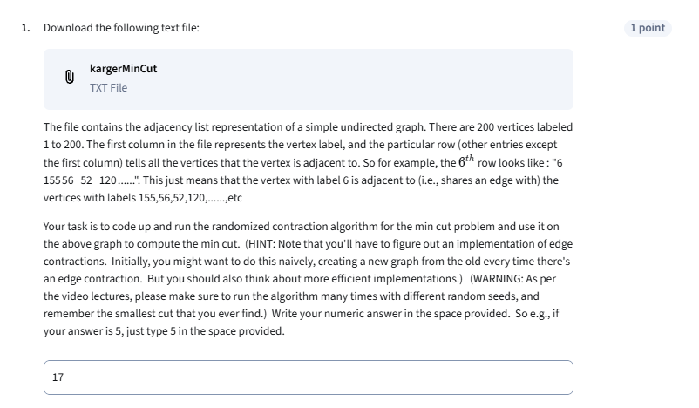

Final Exam For Chapter Divide and Conquer
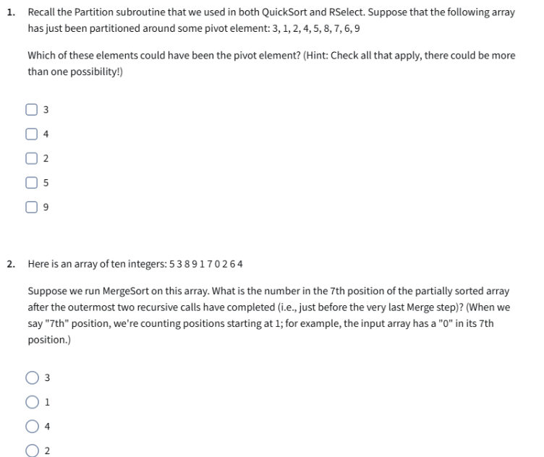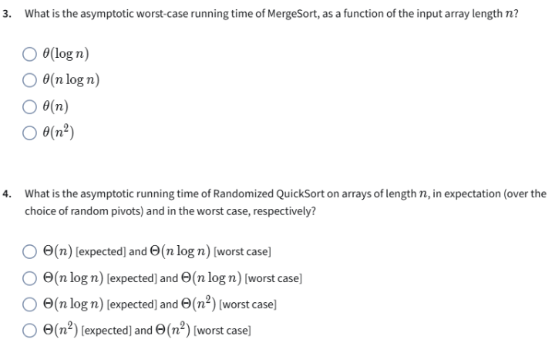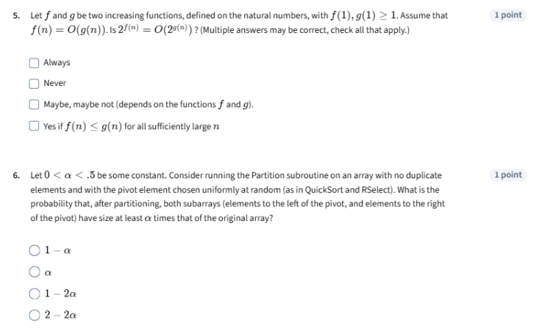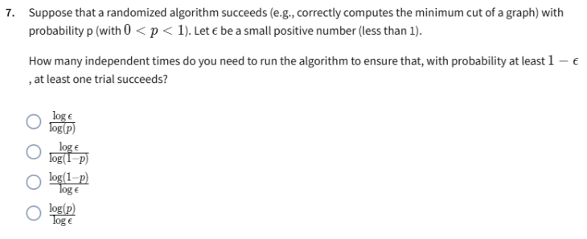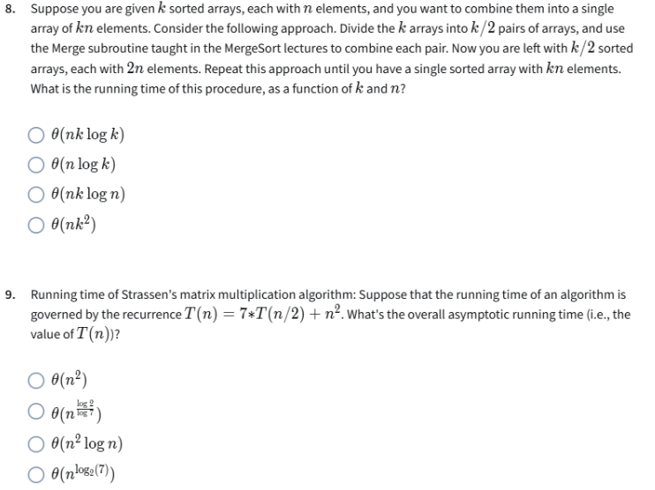
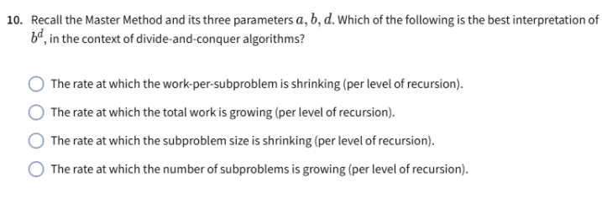
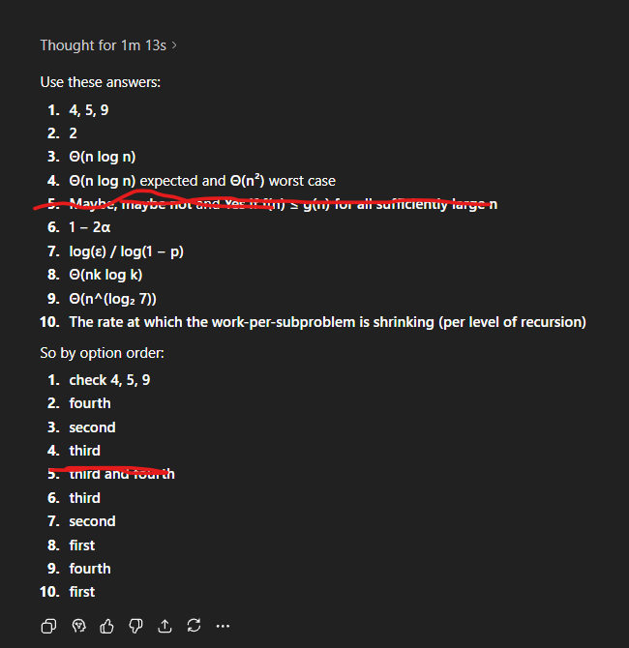

====================================================================
2. Graph Search, Shortest Paths, and Data Structures: Resources ->
Week 1:

Week 2:
Week 3:
Week 4:

